Learning Outcome 1:

Demonstrate an understanding of the functions of computer system components
(Functional Components of a Computer System)

Part 1
Draw a clearly annotated diagram detailing the major components of a computer system and the interconnecting bus connections.

Your diagram must contain:

- CPU
- Memory
- I/O Interface
- 3 Major Bus connections

Demonstrate an understanding of the functions of computer system components
(Functional Components of a Computer System)

Part 2
Write short notes on the functions of each of the following components:

The CPU

Main Memory

I/O Interface

DMA

The 3 System Buses
1.
2.
3.

Learning Outcome 1

Demonstrate an understanding of the functions of computer system components
(Physical and Functional Characteristics of Memory)

Part 1
This question includes 5 abbreviations for commonly used memory types. For each provide:

- An expansion of the abbreviation (if applicable)
- Brief description of function within a system.

EEPROM stands for …
Description:

Flash Memory is …
Description:

DRAM stands for …
Description:

PROM stands for …
Description:

SRAM stands for …
Description:

Part 2
Describe the terms Access Speed and Cycle Speed in relation to memory:
Access Speed & Cycle Speed

Learning Outcome 1

Demonstrate an understanding of the functions of computer system components
(Communicating with Peripheral Devices)

Read the following scenarios then decide on whether each scenario describes an interrupt driven or a polling mechanism. Write a disadvantage of the approach you have chosen.

Scenario 1
A technician is designated as the technical support contact for this month. Every 90 minutes the technician is required to visit each department in turn to find out if there are any problems.

Interrupt Driven or polling technique?
Disadvantage:

Scenario 2
A technician is designated as the technical support contact for this month. PC users contact the technician on the technician’s mobile phone. The PC user has to state their location as part of the fault reporting procedure. As soon as a fault is reported, the technician is required to go immediately to the assistance of the user who has reported the fault.

Interrupt Driven or polling technique?
Disadvantage:

Learning Outcome 1

Demonstrate an understanding of the functions of computer system components
(Read/Write Operations)

Detail the steps involved in a CPU reading from a memory location:

Detail the steps involved in a CPU writing to an I/O port:

Learning Outcome 1:

Demonstrate an understanding of the functions of computer system components
(Interpret Graphical/Tabular Information from Supplied Materials)

A memory manufacturer produces a range of memory devices with various cycle times and data throughput rates. A requirement has been identified for a memory device that has a data throughput slower than 2000MB/s and a memory cycle time faster than 2.5ns.

Using the two graphs supplied for memory devices list all devices that would meet the above requirements. Correctly complete table 1 and table 2 with your findings.

Graph 1
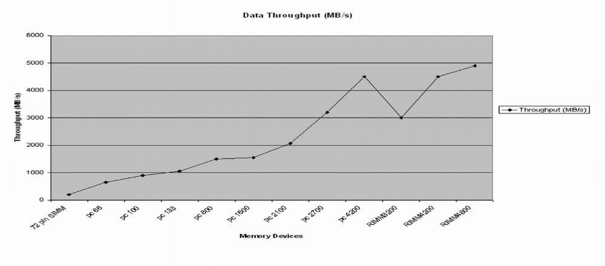

Graph 2
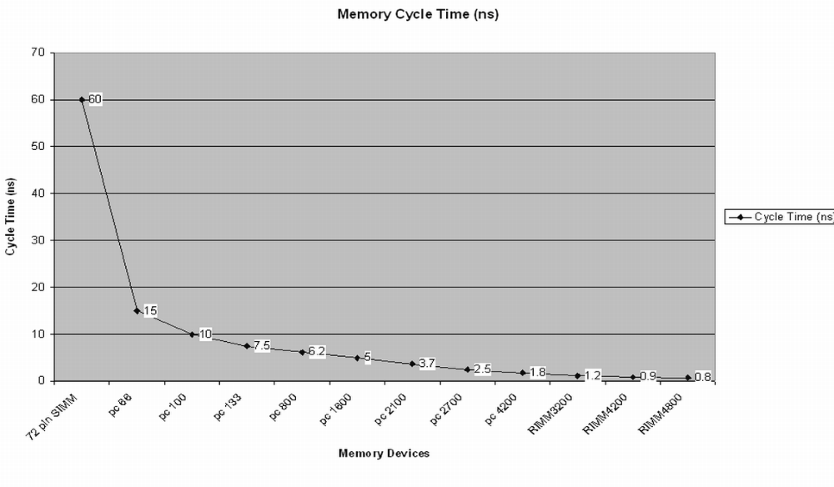

Table 1: Devices with throughput slower than 2000MB/s |  | Table 2: Devices Cycle Time faster than 2.5 ns

